1. Architecture
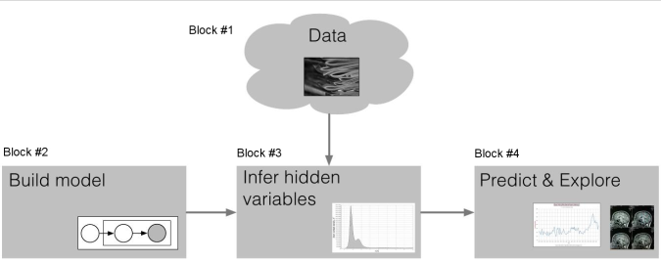

Block #2: Probabilistic vs. non-probabilistic model
Probabilistic models: Probability distributions defined on data, e.g.,
1. Bayes classifiers
2. Logistic regression
3. Least squares and ridge regression (using ML and MAP interpretation)
4. Bayesian linear regression
Non-probabilistic models: No probability distributions involved, e.g.,
1. Perceptron
2. Support vector machine
3. Decision trees
4. K-means
Example: probabilistic model - Gaussian Distribution
Assume i.i.d (identically independent distribution)
write joint density/joint likelihood: 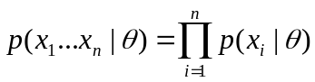
***density Vs likelihood:
Generally, they are the same thing. However, 'density' differs from 'likelihood' in that 'density' doesn't need to be strictly a probability distribution, while 'likelihood' has to be one.
For example, p(x)∝x on [0,1] gives you a density function but it's not by itself a probability distribution. To find the 'likelihood', you would need to integrate this density to find the normalizing constant and find p(x)=2x on [0,1]

Block #3: Algorithms to learn parameters (if it’s a probabilistic model, this process called inference.)
Example: Maximum Likelihood Estimation
make data most probable=>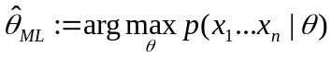
arg means we care only about the value parameter/argument, so don’t need to return the value of joint likelihood.

2. Category
Supervised learning: Given data sets have right answers. Use algorithm to find more answers for other data.
Regression: predict continuous valued output. Output (Y axe) is continuous.
Classification: Output is discrete.
Unsupervised learning: given data, but no answer. Find data structure
clustering
hard clustering(assigns each observation to only one cluster): k-means
soft clustering: weighted k-means, mixture models

3. Linear Regression

3.1 Definition
A regression method is called linear if the prediction f is a linear function of the unknown parameters w.
Basic model: 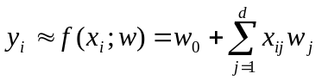
Linear Regression is linear in the weights, not in the input data. So the following is still a linear regression function.
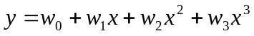

3.2 Least square

3.2.1 objective function
Least square objective: to pick the w that minimizes the sum of squared errors
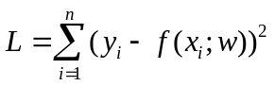
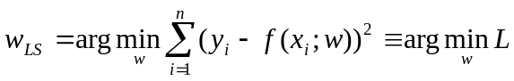

why use square?
-subtract maybe negative

3.2.2 solve parameter from objective function (expression in vector and matrix)
X is a n*(d+1) matrix, n is the dataset size, d is the number of feature.
each feature is a column vector
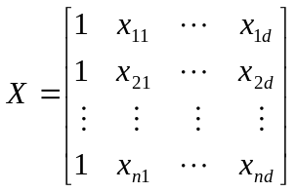

the first column is for w0
Let 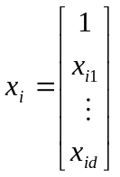, then least square objective can be written as : 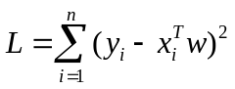

Solve:
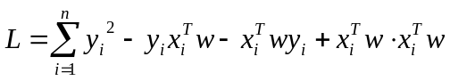
两个标量数字相乘可以交换位置=>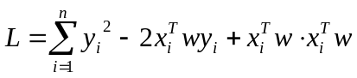
写成能够使用以下矩阵求导公式的形式=>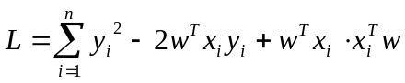
Let 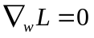=>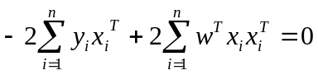
两边取转制 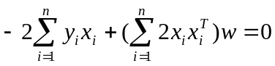=>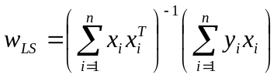

matrix deviation:
d(A∗x)/dx=A
d(x^{T}∗A)/dx^{T}=A
d(x^{T}∗A)/dx=A^{T}
d(x^{T}∗A∗x)/dx=x^{T}(A^{T}+A)

It’ s the vector version.
Convert to matrix version: 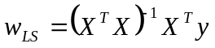

***矩阵相乘的意义其实是多个多项式运算的结果
Example:
小明今天要做饭，消耗2斤肉，1斤蔬菜。肉每斤20元，蔬菜每斤5元，则一共需多少花费？
这个问题的答案很简单：20x2+5x1=45
我们用向量相乘的方法写出来：
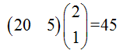
如果小明第二天有另一种做饭的方法，需要消耗1斤肉，4斤蔬菜，那么这两种方法的花费各是多少呢？把这个做饭方式写在第二个矩阵里：
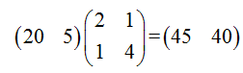
小明家附近还有另一个菜市场，那里肉每斤15元，蔬菜每斤10元。那么，小明如果去这个菜市场，花费又是多少呢（分别计算上述两种做饭方式）？我们把这另外的一种价格写进第一个矩阵里：
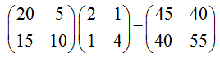
这样我们看到了一个矩阵乘法的例子。在左边的这个矩阵的每一行，都代表了一种价目表；在右边的矩阵的每一列，都代表了一种做饭方式。那么所有可能的组合所最终产生的花费，则在结果矩阵中表示出来了。

Potential issues: Calculating assumes 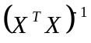 exists.
When doesn’t it exist?
Answer: When is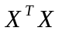 not a full rank matrix.
When is a full rank matrix?
Answer: When the n x (d+1) matrix X has at least d+1 linearly independent rows. Obviously if n< d+1, 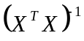 doesn’t exist, there are an infinite number of possible solutions. We can’t do least squares. So we want n >> d (i.e., X is “tall and skinny”)

3.2.3 solve parameter from MLE
Solution:
The gradient is complex to compute => Logarithm trick =>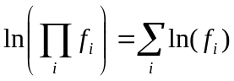
let 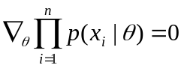 =>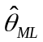

Least square: 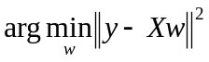⬄ maximum likelihood: 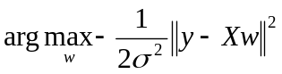

3.2.4 mean and variance of parameter
mean of the solution
variance of the solution
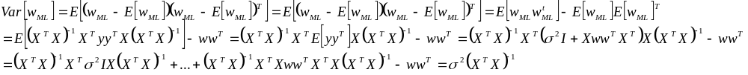
under the Gaussian assumption y ∼ N(Xw, σ²I), when variance are large, it’s bad.

3.2.5 bias and variance of y0
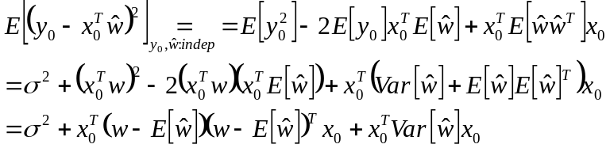

We see that the generalization error is a combination of three factors:
1. Measurement noise - – we can’t control this given the model.
2. Model bias -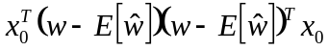 – how close to the solution we expect to be on average.
3. Model variance -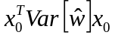 – how sensitive our solution is to the data.

3.3 Regularized Least Squares (Ridge regression)

3.3.1 objective function
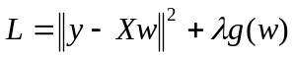
λ>0, g(w) > 0 => penalize (decrease influence) of some parameter

Ridge regression: 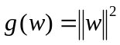 - address variance issue (overfitting issue).

3.3.2 solve parameter from objective function
Objective function:
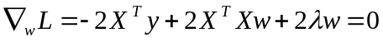=>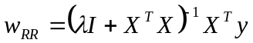

3.3.3 solve parameter from BAYES RULE (MAP)
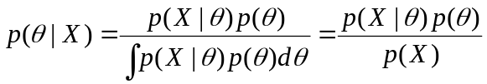
- p(X|θ) is the likelihood, known from the model definition.
- p(θ) is a prior distribution that we define.
- Given these two, we can (in principle) calculate posterior p(θ|X).

Maximum a posterior (MAP) estimation
MAP inference returns the maximum of the log joint likelihood.
Joint Likelihood : p(y, w|X) = p(y|w, X)p(w)
if in a Bayesian setting, we model this data as:
Likelihood : y ∼ N(Xw, σ²I)
Prior : w ∼ N(0, λ⁻¹I)
We saw that this solution for wMAP is the same as for ridge regression:
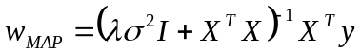⬄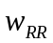
Conclusion: RR maximizes the posterior, while LS maximizes the likelihood.

3.3.4 mean and variance of parameter
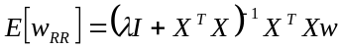,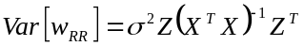where 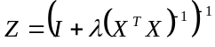
Multiply by Z is to shrink variance, but biased.

3.3.5 Express parameter in the form of SVD
SVD: SINGULAR VALUE DECOMPOSITIONS
We can write any n x*d matrix X (assume n>d) as 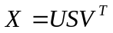,where
- U: n*d and orthonormal in the columns, i.e. 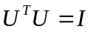
- S: d*d non-negtive diagonal matrix, i.e. 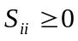 and 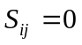 for 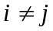
- V: d*d and orthonormal, i.e. 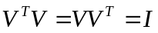

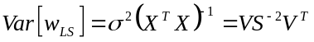
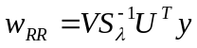, 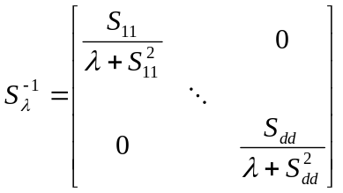
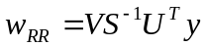 is the case where λ = 0 above

posterior distribution (mean and variance)
For those that doesn’t have w(like denominator), ignore, for it’s just result.
And plug in prior and likelihood. The posterior often has the distribution like prior with different parameters.
so we can multiply a constant and make it like a normal distribution:

predictive distribution
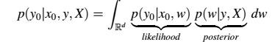
Find the distribution.

3.4 underdetermined problem
X is wide, we have infinite solution for w, how can we pick one?
Least Norm Solution:
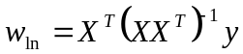, Like least square, but from X^{T}X to XX^{T} to ensure invertible.
Prove:
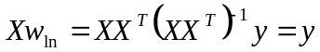

Other solutions:
We can add a δ as long as Xδ = 0 and δ ≠ 0
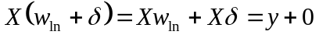

We can prove 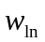 satisfies:
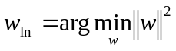 subject to Xw = y (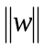is vector norm, 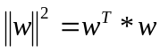)
proof I: Let w be another solution to Xw = y, so 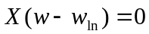, Also

Proof II: Lagrange multipliers
要求 f ( x , y )在 g ( x , y ) = c时的最大值时，我们可以引入新变量拉格朗日乘数 λ,这时我们只需要下列拉格朗日函数的极值：L ( x , y , λ ) = f ( x , y ) + λ ⋅ ( g ( x , y ) − c )
So we hope to get 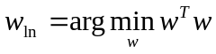 subject to Xw=y, we introduce Lagrange multipliers:
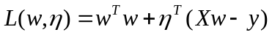
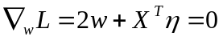,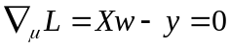,
=>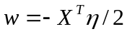,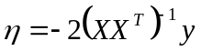
=>

Sparse l1 regression
l1: not square, it’s absolute value
LASSO: we replace the l2 penalty with an l1 penalty:
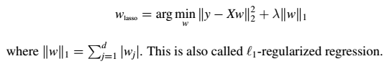
We won’t penalize large value more to the small value
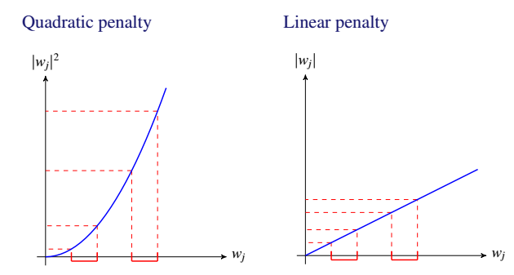
use l1 to achieve sparsity

more generalized expression:
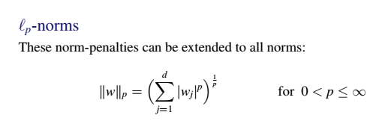
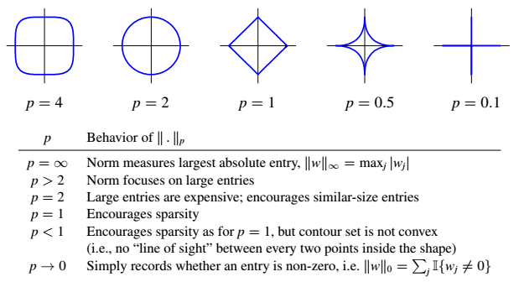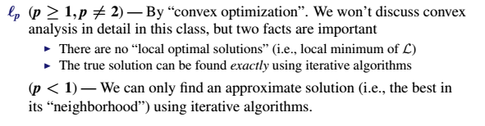

Classification

Nearest Neighbor Classifiers(k-NN classifier)
For an input x not in the training data,
1. Let xi be the point among x1, x2,…, xn that is “closest” to x.
2. Return its label yi.

Question: How should we measure distance between points?
For example, lp for 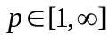: 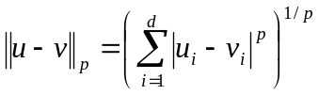
When p =2, it’s Euclidean distance.

k-NEAREST NEIGHBORS CLASSIFIER
This can avoid some mistakes
For a new input x,
1. Return the k points closest to x, indexed as xi1,…,xik.
2. Return the majority-vote of yi1; yi2,…,yik.

Bayes Classifier

definition
Key assumption: Data (x1, y1),…, (xn, yn) are i.i.d. random labeled examples with distribution P.

Indicator
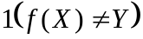 is an indicator function, when 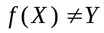, it equals to 1, otherwise it equals to 0.
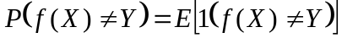
Because the expectation of an indicator of an event is the probability of the event, e.g.,
EP[1(Y = 1)] = P(Y = 1)

Because “tower property” of expectation: C=E[A|B]=>E[C]=E[E[A|B]]=E[A]

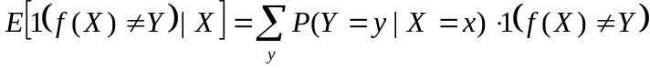 minimized when 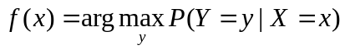 (因为此时0最多)
Because we don’t know the distribution of 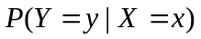, we use Bayes rule.

Bayes rule
From Bayes rule and ignore denominator for it doesn’t contain y,
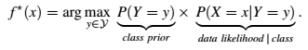
- P(Y = y) is called the class prior. class prior can be different depending on different value of y
- P(X = x|Y = y) is called the class conditional distribution of X.
- In practice we don’t know either of these, so we approximate them.
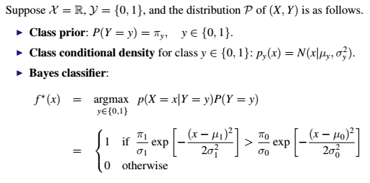

Advantage & Disadvantage
Advantage: The Bayes classifier has the smallest prediction error of all classifiers.
Disadvantage: we can’t construct the Bayes classifier without knowing P.
->Solution: Plug-in classifiers
Use the available data to approximate P(Y = y) and P(X = x|Y = y).
Of course, the result may no longer give the best results among all the classifiers we can choose from

f(x)
Binary classification is one kind of linear classification.
In the binary case, we declare class y = 1 if
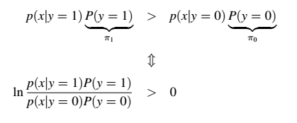
Gaussian with shared covariance
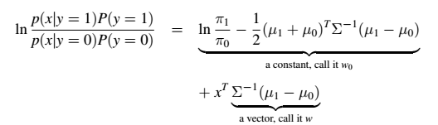
This is also called “linear discriminant analysis”
rewrite bayes classifier as binary classifier:
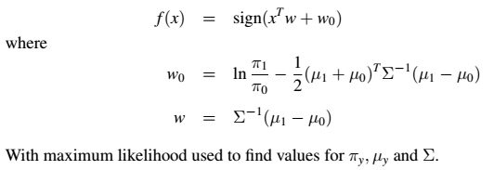
sign means we only keep the sign(positive or negative)

***Gaussian with different covariance
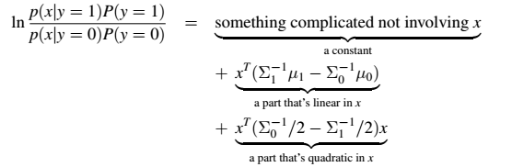

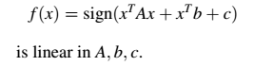
Also called “quadratic discriminant analysis,” but it’s linear in the weights. For example,
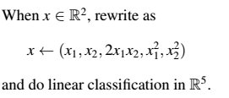

hyperplane
The pair (w, w0) defines an affine hyperplane.
What is hyperplane?
w0=0
A hyperplane in R^{d} is a linear subspace of dimension (d - 1).
hyperplane is always perpidicular to the vector w. for example, 2-dementional space:
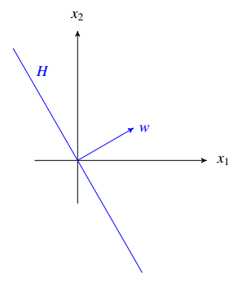

So the sign of cos(·) tells us the side of H, and by the cosine rule: sign(cos θ) = sign(x^{T}w)
*** ||2 means l2 normal rule

The pair (w, w0) defines an affine hyperplane. It is important to develop the right geometric understanding about what this is doing.
What is affine hyperplane?
Think of: H = x^{T}w + w0 = 0.
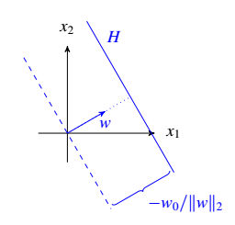
The plane has been shifted by distance 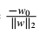 in the direction w.
For a given (w, w0) and input x the inequality x^{T}w + w0 > 0 says that x is on the far side (in the direction vector w is pointing) of an affine hyperplane H in the direction w points.
*** near side: the other side

Method I: Least square
Difference: objective function
Least square objective function is sensitive to outliers
- (left) Least squares (purple) does well compared with another method
- (right) Least squares does poorly because of outliers

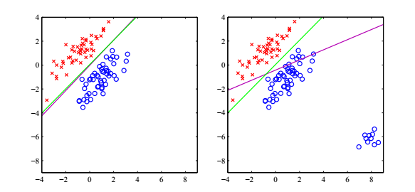
while for binary classification, it only cares sign, so it doesn’t have this problem.

Method II: The perceptron algorithm
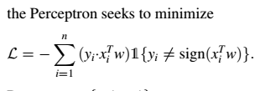
What’s 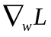?
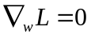 cannot be solved for w analytically.
However does tell us the direction in which L is increasing in w.
Input: Training data 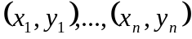 and a positive step size
Step 1: Initialize 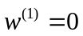
Step2: For iteration t = 1,2,… do
- Search for all examples 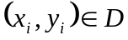 such that 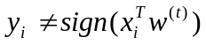
- If such a 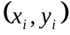 exists, randomly pick one and update 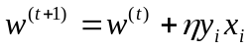
else return 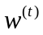 as the solution since everything is classified correctly.
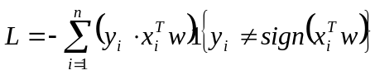, 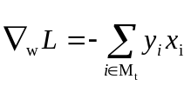, 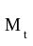 indexes the misclassified observations at step t

DRAWBACKS OF PERCEPTRON:
1. When the data is separable, there are an infinite # of hyperplanes.
2. When the data isn’t separable, the algorithm doesn’t converge. The hyperplane of w is always moving around.

LOGISTIC REGRESSION

Logistic link function
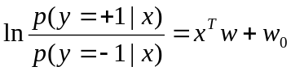

sigmoid function
Setting p(y = -1|x) = 1 - p(y = +1|x), plug into the above logistic link function:
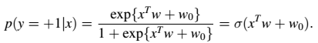

when x^{T}w is going more positive side, then σ is closer to 1. Other wise, σ is closer to 0.

Discriminative vs Generative classifiers
I This is a discriminative classifier because x is not directly modeled.
I Bayes classifiers are known as generative because x is modeled.
Discriminative: p(y|x) Generative: p(x|y)p(y)

Data likelihood
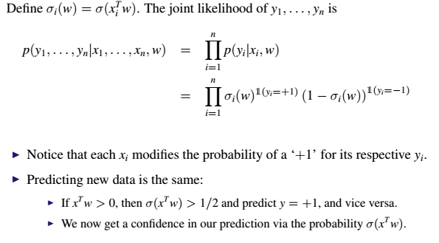
Can be written as:
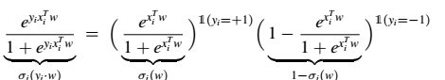
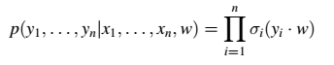
maximize this- maximum likelihood
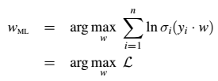
As with the perceptron:
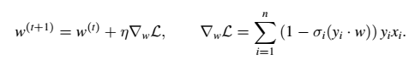
Instead search for misclassified in perceptron, update 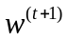 for each
Input: Training data and a positive step size
Step 1: Initialize 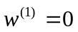
Step2: For iteration t = 1,2,… do
update 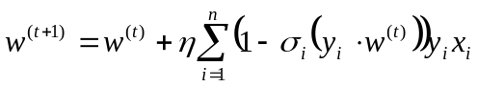

LAPLACE APPROXIMATION

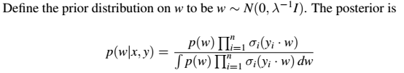Can we approximate posterior distribution p(w|x, y)?
Assume p(w|x, y) ≈ Normal(µ,Σ)
How to get µ,Σ?
From Bayes rule, 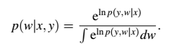
Let’s define f(w) = ln p(y, w|x). Laplace approximation is to approximate f(w) with a second order Taylor expansion.
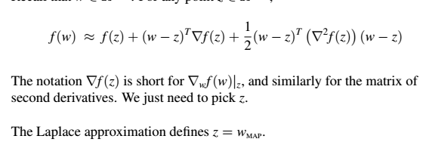
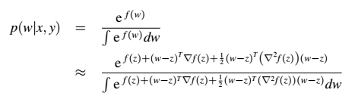
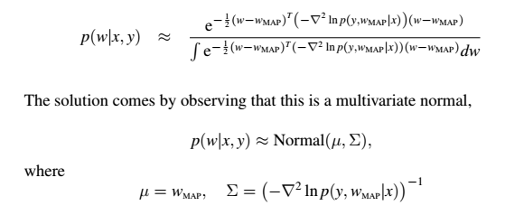

Training methods

CROSS-VALIDATION
The procedure for K-fold cross-validation is very simple:
1. Randomly split the data into K roughly equal groups.
2. Learn the model on K - 1 groups and predict the held-out Kth group.
3. Do this K times, holding out each group once. 每组都当一次evaluation group，共K次
4. Evaluate performance using the cumulative set of predictions.

The data you test the model on should never be used to train the model!

Active learning
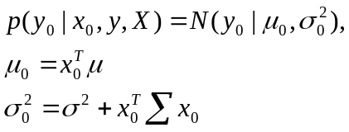

For each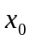, 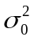 tells how confident we are. This suggests the following:
1. Form predictive distribution p(y0|x0, y, X) for all unmeasured x0 є D
2. Pick the x0 for which is largest and measure y0
3. Update the posterior p(w|y, X) where y (y, y0) and X (X, x0), namely plug x0 and y0 into training set
4. Return to #1 using the updated posterior

Feature expansion (Kernel)

kernel
One method of feature expansion is called “kitchen sink”:
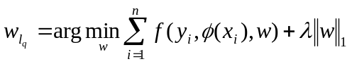
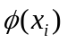 is to expand feature, for example, 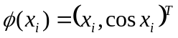
Often we don’t need know , we only need to work with dot products φ(xi)^{T}φ(xj) ≡ K(xi, xj). This is called a kernel.
kernel is a function taking two vectors: Kij = K(xi, xj), where x1,…, xn є Rd and construct the n × n matrix K.
The output is a positive real value number.

why only need know kernel?
Perceptron classifier:
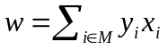
where M is the sequentially constructed set of misclassified examples
Predicting new data: 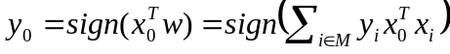
Feature expansion:

Gaussian Kernel

By far the most popular kernel is the Gaussian kernel, also called the radial basis function (RBF).
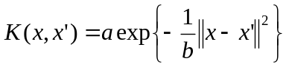
When getting closer and closer, it’s a. Otherwise, it’s 0. b defines what is close.
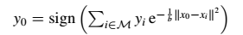

kernelized Perceptron

1. Find a new x’ such that
2. Add the index of x’ to M but don’t bother calculating w^{(t+1)}

kernelized K-nn
- Instead of summing over misclassified data M, sum over all the data:
- the decision doesn’t change if we divide by a positive constant

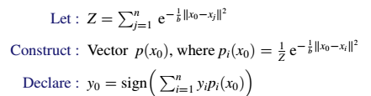

KERNEL REGRESSION
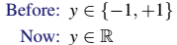
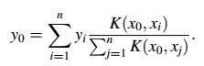
y0 is predicted as the average of its neighbors.

Gaussian process
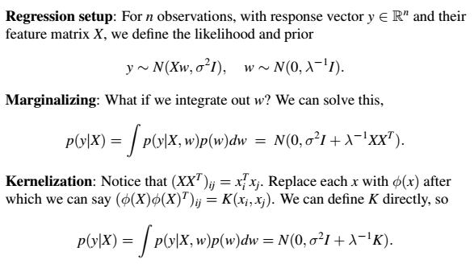

MAXIMUM MARGIN CLASSIFIERS

Introduce
maximize the margin

convex hull: the smallest convex set which contains all point in the class
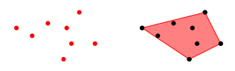

How to define a convex hull?
Every point x0 in the shaded region can be reached by setting
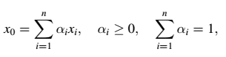
No point outside this region can be reached this way.

margin: the shortest distance between the hyperplane H and any point in either set
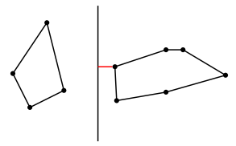
How to find H?
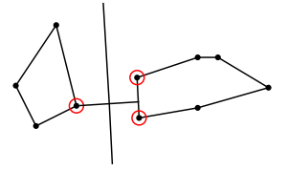
1: Find the closest two points within the convex hulls of classes +1 and -1. (moving through the convex margin)
2: Connect them with a line and put a perpendicular hyperplane in the middle.
3: If S1 and S0 are the sets of x in class +1 and -1 respectively, we’re looking for two probability vectors α1 and α0 such that we minimize
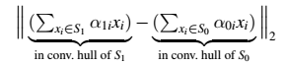
4: Then we define the hyperplane using the two points found with α1 and α0.

support vector machine
pick up some data pairs

Primal problem
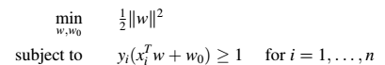
This is tricky, so we use Lagrange multipliers to set up the “dual” problem.
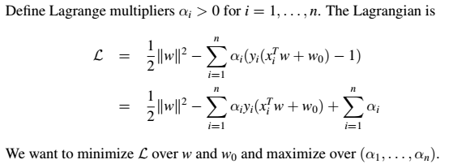
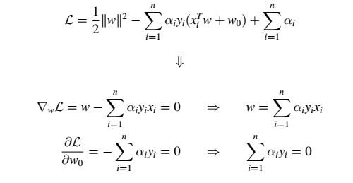
plugging in these values
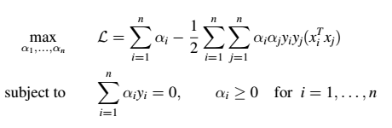
Comments
I Where did w0 go? The condition 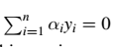gives 0 · w0 in the dual.
I We now maximize over the αi. This requires an algorithm that we won’t discuss in class. Many good software implementations are available.
αi is positive meaning the corresponding vector in 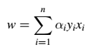 is a supporting vector. otherwise if it = 0 , means it’s not.

What does the dual problem mean?
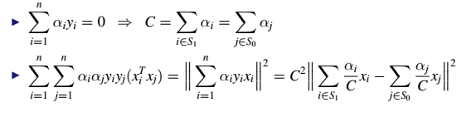
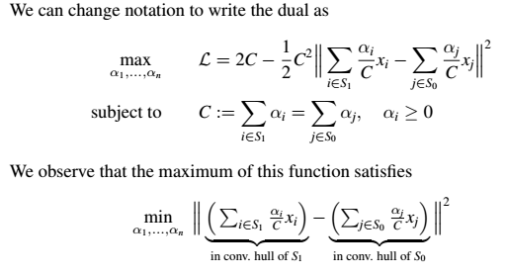
Therefore, the dual problem is trying to find the closest points in the convex hulls constructed from data in class +1 and -1.
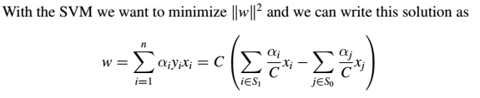

SOFT-MARGIN SVM
What if the data isn’t linearly separable? - SOFT-MARGIN SVM
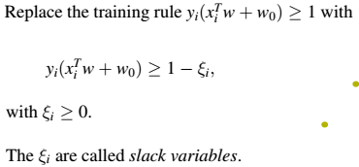

Soft-margin objective function
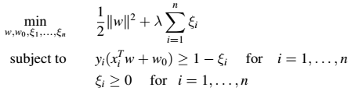
Role of λ
I Specifies the “cost” of allowing a point on the wrong side.
I If λ is very small, we’re happy to misclassify.
I For λ ->∞, we recover the original SVM because we want ξi = 0.
I We can use cross-validation to choose it.

Dual problem
Maximize over each (αi, µi) and minimize over w, w0, ξ1,…,ξn
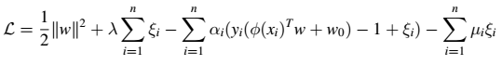
=> 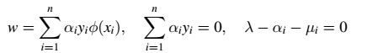
If we plug w and µi = λ - αi back into the L, we have the dual problem

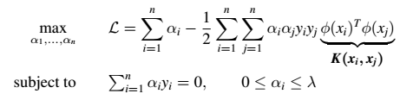

DECISION TREES
Everything in the same region has the same prediction.
step: split in the first dimension, then second dimension…
Example1:
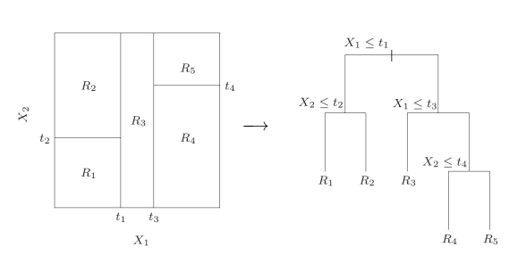
Examle2:
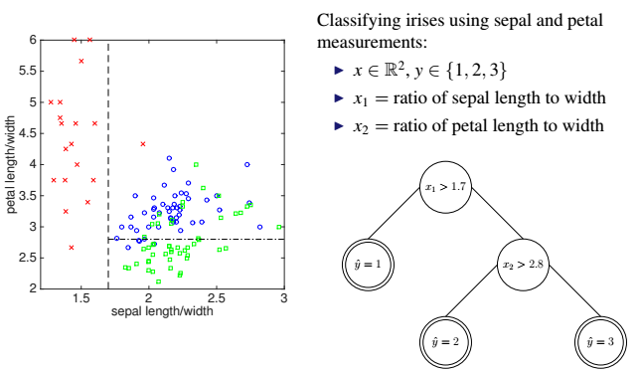

Regression tree
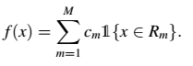
Goal: minimize 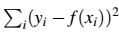
Find cm given Rm: Simply the average of all yi for which xi є Rm.
For each region R(leaf node)
for each dimension j
determine the splitting point s

Classification tree
For regression: Squared error is a natural way to define the splitting rule.
For classification: let pk be empirical fraction labeled k, minimize one of the following rule:
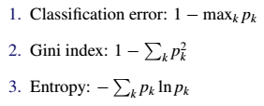
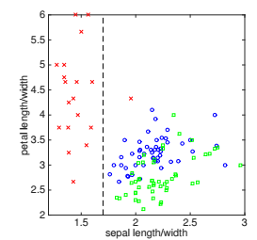
R2: 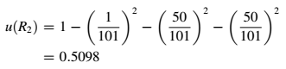
Then continue to split R2 into :
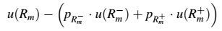
if split in dimension x1:
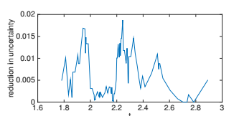
if split in dimension x2
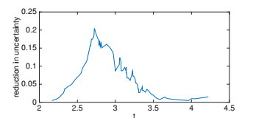
about 2.8

Q: When should we stop growing a tree?
Pruning is the method most often used. (Pruning a tree)

Random forest and Boosting

bootstrap
Bootstrap algorithm
1. Generate bootstrap samples B1,…, BB.
• Create Bb by picking points from {x1,…, xn} randomly n times. (pick with return)
• A particular xi can appear in Bb many times (it’s simply duplicated).
2. Evaluate the estimator on each Bb by pretending it’s the data set:
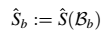
*for example, in one dimension feature, 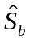can be the median of Bb
3. Estimate the mean and variance of
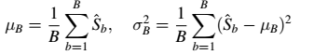

Random forest
Bagging uses the bootstrap for regression or classification:
1. Draw a bootstrap sample Bb of size n from training data.
2. Train a classifier or regression model fb on Bb.
I For a new point x0, compute: 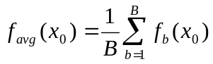
I For regression, favg(x0) is the prediction.
I For classification, view favg(x0) as an average over B votes. Pick the majority

Advantage: Bagging often improves results when the function is non-linear.
Disadvantage: the bagged trees are correlated. when bootstrap samples are correlated, the benefit of bagging decreases.
Solution: random forest - only consider random subset of dimensions

For b = 1,…, B:
1. Draw a bootstrap sample Bb of size n from the training data.
2. Train a tree classifier on Bb, where each split is computed as follows:
I Randomly select m dimensions of xє Rd, newly chosen for each b.
I Make the best split restricted to that subset of dimensions.

Boosting
Overview
like bagging
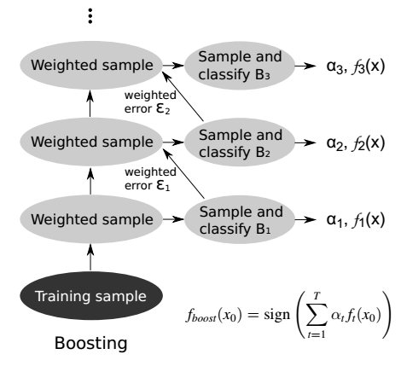
THE ADABOOST ALGORITHM
Given (x1, y1),…,(xn, yn), x є X, y є {-1;+1}, set w1(i) = 1 /n for i = 1 : n
- For t = 1,…,T
1. Sample a bootstrap dataset Bt of size n according to distribution wt.
Notice we pick (xi; yi) with probability wt(i) and not 1/ n.(bagging)
2. Learn a classifier ft using data in Bt.
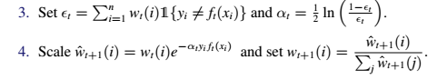
step4 means if classified correctly, the pair will be downweighted.(w be decreased)
- Set the classification rule to be
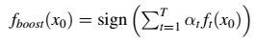

We can boost any classifier.
Boosting a bad classifier is often better than not boosting a good one.
Boosting a good classifier is often better, but can take more time.

Clustering

K-means
The K-means objective function
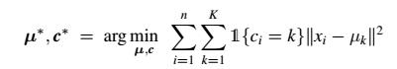
µ is the vector of k centroids, c is the vector of k classes (1,2,…,k)
The objective function is “non-convex”
- This means that we can’t actually find the optimal µ∗ and c∗.
- We can only derive an algorithm for finding a local optimum

We won’t use gradient descent(It may not even move to a better value if the step size η is too big. We also need the parameter to be continuous-valued). Instead, we split the variables into two unknown sets µ and c. We can’t find their best values at the same time to minimize L. However, we will see that
- Fixing µ we can find the best c exactly. -assignment step
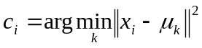
- Fixing c we can find the best µ exactly. -update step
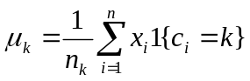, 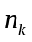is the number of elements in k
This optimization approach is called coordinate descent: Hold one set of parameters fixed, and optimize the other set. Then switch which set is fixed.

The algorithm is convergent, because L is monotonically decreases. L >=0, so it’ll converge to some point.
Algorithm terminates when c stops changing.
Non-convexity means that different initializations will give different results.

Select K: Looking at the relative decrease in L. If K∗ is best, then increasing K when K ≤ K∗ should decrease L much more than when K > K∗.

TWO APPLICATIONS OF K-MEANS
- Lossy data compression
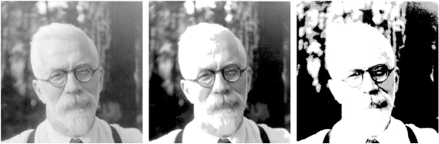
(left) Original 1024×1024 image requiring 8 bits/pixel (1MB total)
(middle) Approximation using 200 clusters (requires 239KB storage)
(right) Approximation using 4 clusters (requires 62KB storage)
- Data processing: This allows us to recast a continuous-valued problem as a discrete one.

k-medoids: 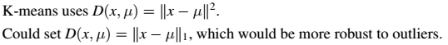

expectation–maximization (EM) algorithm
an expectation–maximization (EM) algorithm is an iterative method to find maximum likelihood or maximum a posteriori (MAP) estimates of parameters in statistical models, where the model depends on unobserved latent variables.

THE EM OBJECTIVE FUNCTION
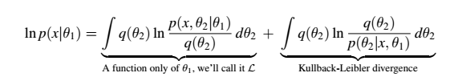
The KL diverence is always ≥ 0 and only = 0 when q = p.
easy to prove the equation通分+Bayes rule
goal：lnP(x|θ1) is “tricky” to optimize directly. However, we figure out that we can add a second variable θ2

The EM algorithm
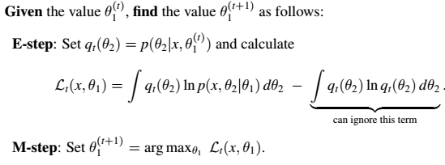

proof:
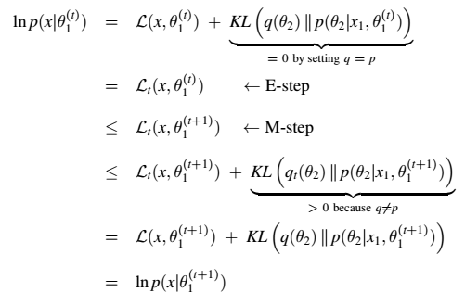

convergence: 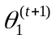 和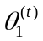会越来越接近=>KL(q||p)->0=>L(X, θ1)与p(X|θ1)越来越接近

EM FOR MISSING DATA
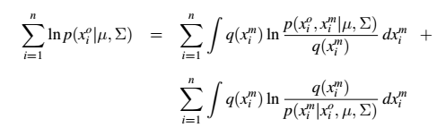
Let 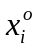 and 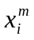 represent the observed and missing dimensions of xi.

weighted k-means
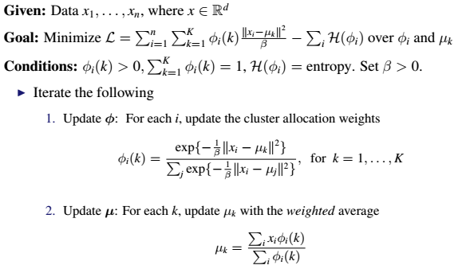
For each Фi(k), the optimal case is has one 1 and all others 0. far from center will lead to small Фi(k).
When When ϕi is binary, we get back the hard clustering model

(Gaussian) Mixture model
It’s a PROBABILISTIC SOFT CLUSTERING MODELS
∏ is the weight, and θ is parameter of Gaussian distribution, ci indexes the cluster assignment.
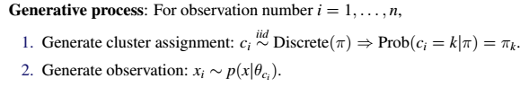
Go is to learn ∏ and θ (not including c)

Objective: Maximize the likelihood over model parameters π, µ and Σ by treating the ci as auxiliary data using the EM algorithm.
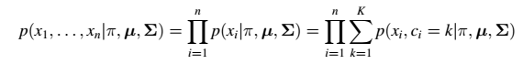
We could use gradient methods(no closed form solution - don’t know when to end), but EM has closed form solution.
From the last lecture, the generic EM objective is
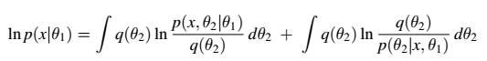
The EM objective for the Gaussian mixture model is
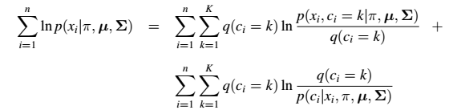
Because ci is discrete, the integral becomes a sum.

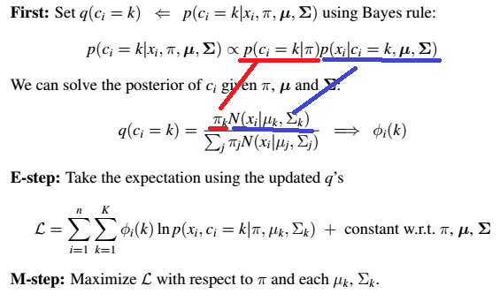
red part: prior
blue part: likelihood
Probabilistic vs non-probabilistic soft clustering
The weight vector φi is like a probability of xi being assigned to each cluster.

Aside: How has EM made this easier?
Original objective function:
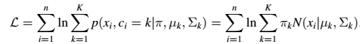
The log-sum form makes optimizing π, and each µk and Σk difficult.
Using EM here, we have the M-Step :
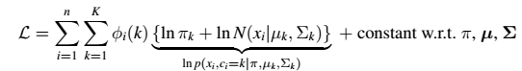
The sum-log form is easier to optimize. We can take derivatives and solve.
take drivatives to 0, we get: ( )

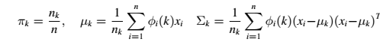

COLLABORATIVE FILTERING
Use previous users’ input/behavior to make future recommendations. Ignore any a priori user or object information.

MATRIX FACTORIZATION
SVD(SINGULAR VALUE DECOMPOSITION ):
Every matrix M can be written as
M = USVT, where UTU = I, VTV = I and S is diagonal with Sii ≥ 0.
r = rank(M). When it’s small, M has fewer “degrees of freedom.” (If lots of rows are similar/correlated, then the degrees of freedom is low. )
Collaborative filtering with matrix factorization is intuitively similar.
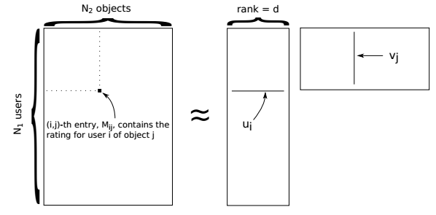
use this method to predict missing values
how to set d is like how to set k in clustering - write now we just fix d and try a few values.

Ω = {(i, j) : Mij is measured} (user i rated object j)
Generative model
For N1 users and N2 objects, generate
User locations: ui ∼ N(0, λ⁻¹I); i = 1,…,N1
Object locations: vj ∼ N(0, λ⁻¹I); j = 1,…,N2
Given these locations the distribution on the data is
Mij ∼ N(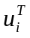vj,σ²); for each (i, j) є Ω

MAP inference coordinate ascent algorithm to get ui and vi
to maximize p(Mo, U, V) over U and V, we have to
1. Write out the joint likelihood
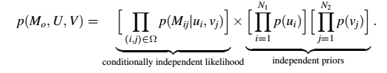
2. Take its natural logarithm
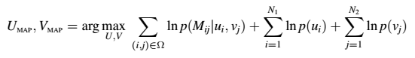
Calling the MAP objective function L, we want to maximize
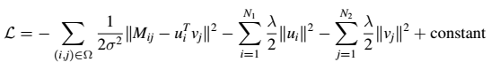
3. Take derivatives with respect to ui and vj and see if we can solve
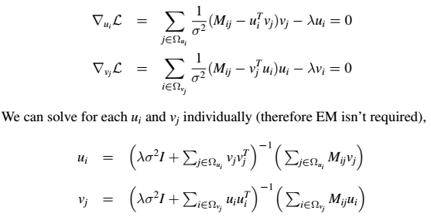
Two parameters=> coordinate ascent algorithm.
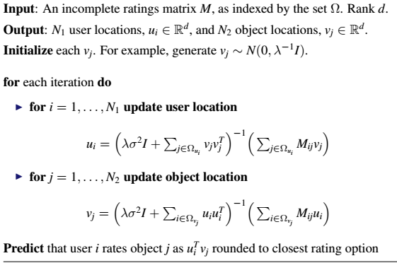

Text
A probabilistic topic model
- Learns distributions on words called “topics” shared by documents
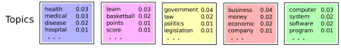
- Assigns every word to a topic, Learns a distribution on topics for each document


LATENT DIRICHLET ALLOCATION(LDA)
The generative process for LDA is:
1. Generate each topic, which is a distribution on words
βk ∼ Dirichlet(γ); k = 1,…, K
2. For each document, generate a distribution on topics
θd ∼ Dirichlet(α); d = 1,…,D
3. For the nth word in the dth document,
a) Allocate the word to a topic, cdn ∼ Discrete(θd)
b) Generate the word from the selected topic, xdn ∼ Discrete(βcdn)

nonnegative matrix factorization (NMF)
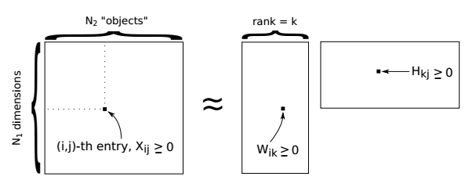
each column: document
each row: word
value: how many times word i occur in docment j

Two objective functions:
Choice 1: Squared error objective
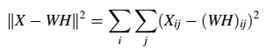
Choice 2: Divergence objective
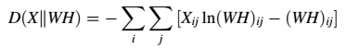

Algorithm
I Randomly initialize H and W with nonnegative values.
I Iterate the following, first for all values in H, then all in W:
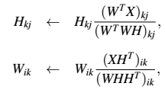
until the change in ||X - WH||² is “small.”

MARKOV CHAINS
So far, when thinking probabilistically we have focused on the i.i.d. setting. In some applications, the distribution on the next value clearly depends on the previous values.
way to model sequential information
first-order Markov chain: depends on the previous position. It’s the simplest type.
second-order Markov chain: depend on the previous two positions.

matrix notation
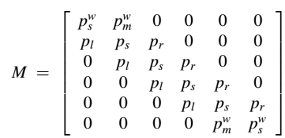
Mij is the probability that the next position is j given the current position is i.
A sequence (s1,…,st) is a first-order Markov chain if
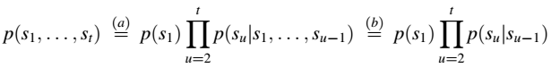
matrix form: Mij = p(st = j|st-1 = i)

any matrix manipulation in numpy is allowed to use, including trace function.

FYI there is a package called hide_code which lets you hide code cells and export to pdf

https://github.com/kirbs-/hide_code

But be sure to save the notebook that you wish to remove the code from as a new notebook before doing this (otherwise you may lose the code and will not be able to recover it)

For part I (a), Y axis is the 7 values in wRR.

